Lab 7: Design and FPGA Implementation of the Register File for a Single-Cycle RISC-V Processor
Objective

Task 1: Register File Block Diagram Design

Block diagram of Register File

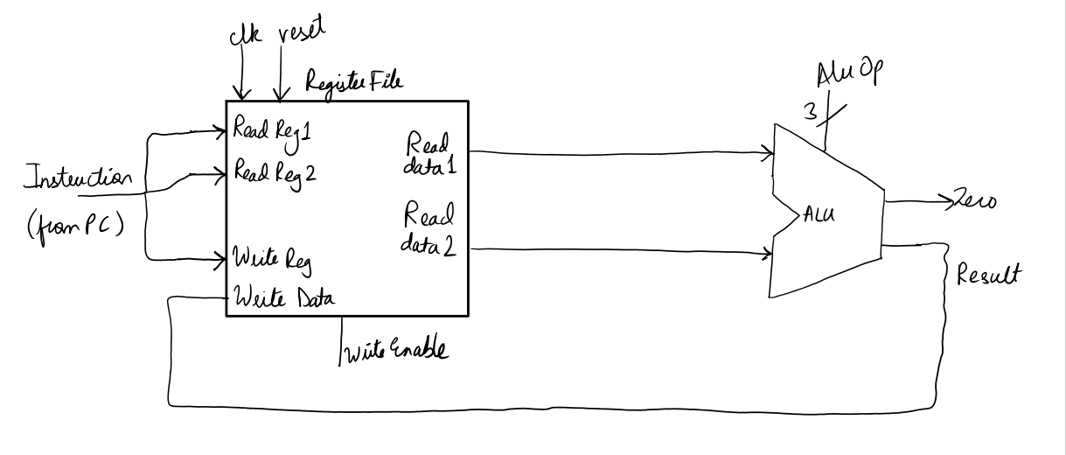

Task 2: Verilog Description and Testbench Development

Verilog source file for Register File
`timescale 1ns / 1ps

module RegisterFile (

input wire clk,

input wire rst,

input wire WriteEnable,

input wire [4:0] rs1, // reg 1

input wire [4:0] rs2, // reg 2

input wire [4:0] rd, // destination reg

input wire [31:0] WriteData,

output wire [31:0] ReadData1, //reg 1 data

output wire [31:0] ReadData2 //reg 2 data

);

reg [31:0] regs [31:0]; //32 registers, each 32 bits wide

integer k; // value 32 for loop

always @(posedge clk or posedge rst) begin

if (rst) begin

//reset clears reg

for (k = 0; k < 32; k = k + 1)

regs[k] <= 32'd0;

end else begin

if (WriteEnable && (rd != 5'd0))

regs[rd] <= WriteData;

end

end

assign ReadData1 = (rs1 == 5'd0) ? 32'd0 : regs[rs1];

assign ReadData2 = (rs2 == 5'd0) ? 32'd0 : regs[rs2];

endmodule

Testbench file for Register File
`timescale 1ns / 1ps

module RegisterFile_tb;

reg clk;

reg rst;

reg WriteEnable;

reg [4:0] rs1, rs2, rd;

reg [31:0] WriteData;

wire [31:0] ReadData1, ReadData2;

RegisterFile uut (

.clk(clk),

.rst(rst),

.WriteEnable(WriteEnable),

.rs1(rs1),

.rs2(rs2),

.rd(rd),

.WriteData(WriteData),

.ReadData1(ReadData1),

.ReadData2(ReadData2)

);

// 100 MHz clock

always #5 clk = ~clk;

task write_reg;

input [4:0] addr;

input [31:0] data;

begin

@(negedge clk); // set up before rising edge

WriteEnable = 1;

rd = addr;

WriteData = data;

@(posedge clk); #1; // capture on rising edge

WriteEnable = 0;

end

endtask

integer pass_count = 0;

integer fail_count = 0;

initial begin

// --- Initialise ---

clk = 0;

rst = 1;

WriteEnable = 0;

rs1 = 0;

rs2 = 0;

rd = 0;

WriteData = 0;

// Release reset after 3 clock cycles

repeat (3) @(posedge clk);

rst = 0;

#1;

write_reg(5'd5, 32'hDEAD_BEEF);

rs1 = 5'd5;

#1; // asynchronous read settles immediately

if (ReadData1 === 32'hDEAD_BEEF) begin

$display("[PASS] Test i : x5 = 0x%08h (correct)", ReadData1);

pass_count = pass_count + 1;

end else begin

$display("[FAIL] Test i : x5 expected 0xDEADBEEF, got 0x%08h", ReadData1);

fail_count = fail_count + 1;

end

write_reg(5'd0, 32'hFFFF_FFFF);

rs1 = 5'd0;

#1;

if (ReadData1 === 32'd0) begin

$display("[PASS] Test ii: x0 = 0x%08h (correctly stays zero)", ReadData1);

pass_count = pass_count + 1;

end else begin

$display("[FAIL] Test ii: x0 expected 0x00000000, got 0x%08h", ReadData1);

fail_count = fail_count + 1;

end

write_reg(5'd10, 32'hCAFE_BABE);

rs1 = 5'd5; // should return 0xDEADBEEF

rs2 = 5'd10; // should return 0xCAFEBABE

#1;

if (ReadData1 === 32'hDEAD_BEEF && ReadData2 === 32'hCAFE_BABE) begin

$display("[PASS] Test iii: Dual read OK rs1=0x%08h rs2=0x%08h", ReadData1, ReadData2);

pass_count = pass_count + 1;

end else begin

$display("[FAIL] Test iii: rs1=0x%08h (exp 0xDEADBEEF) rs2=0x%08h (exp 0xCAFEBABE)",

ReadData1, ReadData2);

fail_count = fail_count + 1;

end

write_reg(5'd5, 32'h1234_5678);

rs1 = 5'd5;

#1;

if (ReadData1 === 32'h1234_5678) begin

$display("[PASS] Test iv : x5 overwritten to 0x%08h (correct)", ReadData1);

pass_count = pass_count + 1;

end else begin

$display("[FAIL] Test iv : x5 expected 0x12345678, got 0x%08h", ReadData1);

fail_count = fail_count + 1;

end

rst = 1;

@(posedge clk); #1;

rst = 0;

rs1 = 5'd5;

rs2 = 5'd10;

#1;

if (ReadData1 === 32'd0 && ReadData2 === 32'd0) begin

$display("[PASS] Test v : Reset OK â€“ x5=0x%08h, x10=0x%08h", ReadData1, ReadData2);

pass_count = pass_count + 1;

end else begin

$display("[FAIL] Test v : After reset x5=0x%08h, x10=0x%08h (expected 0)", ReadData1, ReadData2);

fail_count = fail_count + 1;

end

//

$display("--------------------------------------------------");

$display("RegisterFile_tb: %0d PASSED, %0d FAILED", pass_count, fail_count);

$display("--------------------------------------------------");

$finish;

end

endmodule

Verilog source file for Top-level (top rf alu.v).
`timescale 1ns / 1ps

module top_rf_alu (

input wire clk,

input wire pbin,

input wire [15:0] physical_sw,

output wire [15:0] physical_leds

);

wire rst_clean;

debouncer rst_db (

.clk (clk),

.pbin (pbin),

.pbout(rst_clean)

);

wire [4:0] fsm_rs1, fsm_rs2, fsm_rd;

wire [31:0] fsm_wd;

wire fsm_we;

wire [3:0] fsm_alu_ctrl;

wire [3:0] fsm_state_out;

wire [31:0] rf_rd1, rf_rd2;

wire [31:0] alu_result;

wire alu_zero;

//

RegisterFile RF (

.clk (clk),

.rst (rst_clean),

.WriteEnable(fsm_we),

.rs1 (fsm_rs1),

.rs2 (fsm_rs2),

.rd (fsm_rd),

.WriteData (fsm_wd),

.ReadData1 (rf_rd1),

.ReadData2 (rf_rd2)

);

alu_32bit ALU (

.A (rf_rd1),

.B (rf_rd2),

.ALUControl(fsm_alu_ctrl),

.ALUResult (alu_result),

.Zero (alu_zero)

);

rf_alu_fsm FSM (

.clk (clk),

.rst (rst_clean),

.alu_result(alu_result),

.alu_zero (alu_zero),

.rf_we (fsm_we),

.rf_rs1 (fsm_rs1),

.rf_rs2 (fsm_rs2),

.rf_rd (fsm_rd),

.rf_wd (fsm_wd),

.alu_ctrl (fsm_alu_ctrl),

.state_out (fsm_state_out)

);

switches led_writer (

.clk (clk),

.rst (rst_clean),

.writeData ({16'd0, alu_zero, fsm_state_out, alu_result[10:0]}),

.writeEnable(1'b1),

.readEnable (1'b0),

.memAddress (30'd0),

.readData (),

.leds (physical_leds)

);

endmodule

module rf_alu_fsm (

input wire clk,

input wire rst,

input wire [31:0] alu_result,

input wire alu_zero,

// Register File control

output reg rf_we,

output reg [4:0] rf_rs1,

output reg [4:0] rf_rs2,

output reg [4:0] rf_rd,

output reg [31:0] rf_wd,

// ALU control

output reg [3:0] alu_ctrl,

// Status (for LED display)

output reg [3:0] state_out

);

// ALU control codes - match Lab 6 alu_32bit

localparam [3:0]

CTRL_AND = 4'b0000,

CTRL_OR = 4'b0001,

CTRL_ADD = 4'b0010,

CTRL_SUB = 4'b0110,

CTRL_XOR = 4'b0100,

CTRL_SLL = 4'b1000,

CTRL_SRL = 4'b1001;

localparam [3:0]

S_INIT0 = 4'd0, // write x1 = 0x10101010

S_INIT1 = 4'd1, // write x2 = 0x01010101

S_INIT2 = 4'd2, // write x3 = 5 (shift amount)

S_READ_ALU = 4'd3, // present rs1=x1, rs2=x2, wait for ALU to settle

S_WR_ADD = 4'd4, // write ADD result -> x4

S_WR_SUB = 4'd5, // write SUB result -> x5

S_WR_AND = 4'd6, // write AND result -> x6

S_WR_OR = 4'd7, // write OR result -> x7

S_WR_XOR = 4'd8, // write XOR result -> x8

S_READ_SLL = 4'd9, // present rs1=x1, rs2=x3 for shift ops

S_WR_SLL = 4'd10, // write SLL result -> x9

S_WR_SRL = 4'd11, // write SRL result -> x10

S_BEQ_READ = 4'd12, // SUB x1-x1, check Zero flag

S_BEQ_WR = 4'd13, // write flag -> x11

S_DONE = 4'd14; // stable - hold results, wait for reset

reg [3:0] state;

// Track which op we're writing so we can change alu_ctrl in the WRITE state

// without losing the correct result

reg [3:0] saved_ctrl;

always @(*) state_out = state[3:0];

always @(posedge clk or posedge rst) begin

if (rst) begin

state <= S_INIT0;

rf_we <= 0;

rf_rs1 <= 0; rf_rs2 <= 0;

rf_rd <= 0; rf_wd <= 0;

alu_ctrl <= CTRL_ADD;

saved_ctrl <= CTRL_ADD;

end else begin

// Default: no write

rf_we <= 0;

case (state)

S_INIT0: begin

rf_we <= 1; rf_rd <= 5'd1; rf_wd <= 32'h10101010;

state <= S_INIT1;

end

S_INIT1: begin

rf_we <= 1; rf_rd <= 5'd2; rf_wd <= 32'h01010101;

state <= S_INIT2;

end

S_INIT2: begin

rf_we <= 1; rf_rd <= 5'd3; rf_wd <= 32'd5;

// Point rs1/rs2 at x1,x2 and set first op ready for next cycle

rf_rs1 <= 5'd1; rf_rs2 <= 5'd2; alu_ctrl <= CTRL_ADD;

state <= S_READ_ALU;

end

S_READ_ALU: begin

rf_rs1 <= 5'd1; rf_rs2 <= 5'd2;

// alu_ctrl is already ADD (set in INIT2 or carried forward)

state <= S_WR_ADD;

end

// Write ADD result (alu_result is now ADD of x1,x2)

S_WR_ADD: begin

rf_we <= 1; rf_rd <= 5'd4; rf_wd <= alu_result;

// Change op for next read

rf_rs1 <= 5'd1; rf_rs2 <= 5'd2; alu_ctrl <= CTRL_SUB;

state <= S_WR_SUB;

// NOTE: We stay with rs1/rs2=x1,x2 and just changed alu_ctrl.

// alu_result will reflect SUB on the NEXT posedge so we need

// one more cycle before writing. Go back through READ.

// Actually: since alu_ctrl<=CTRL_SUB takes effect NEXT cycle,

// alu_result this cycle is still ADD - that's fine, we wrote it.

// Next cycle state=S_WR_SUB and alu_result will be SUB.

// This works because alu_ctrl and rs1/rs2 are set together.

end

S_WR_SUB: begin

rf_we <= 1; rf_rd <= 5'd5; rf_wd <= alu_result;

rf_rs1 <= 5'd1; rf_rs2 <= 5'd2; alu_ctrl <= CTRL_AND;

state <= S_WR_AND;

end

S_WR_AND: begin

rf_we <= 1; rf_rd <= 5'd6; rf_wd <= alu_result;

rf_rs1 <= 5'd1; rf_rs2 <= 5'd2; alu_ctrl <= CTRL_OR;

state <= S_WR_OR;

end

S_WR_OR: begin

rf_we <= 1; rf_rd <= 5'd7; rf_wd <= alu_result;

rf_rs1 <= 5'd1; rf_rs2 <= 5'd2; alu_ctrl <= CTRL_XOR;

state <= S_WR_XOR;

end

S_WR_XOR: begin

rf_we <= 1; rf_rd <= 5'd8; rf_wd <= alu_result;

// Switch to shift ops: rs2=x3 (shift amount=5)

rf_rs1 <= 5'd1; rf_rs2 <= 5'd3; alu_ctrl <= CTRL_SLL;

state <= S_READ_SLL;

end

// One settle cycle for SLL (rs2 changed to x3)

S_READ_SLL: begin

rf_rs1 <= 5'd1; rf_rs2 <= 5'd3; alu_ctrl <= CTRL_SLL;

state <= S_WR_SLL;

end

S_WR_SLL: begin

rf_we <= 1; rf_rd <= 5'd9; rf_wd <= alu_result;

rf_rs1 <= 5'd1; rf_rs2 <= 5'd3; alu_ctrl <= CTRL_SRL;

state <= S_WR_SRL;

end

S_WR_SRL: begin

rf_we <= 1; rf_rd <= 5'd10; rf_wd <= alu_result;

// BEQ: point both ports at x1 for SUB x1-x1

rf_rs1 <= 5'd1; rf_rs2 <= 5'd1; alu_ctrl <= CTRL_SUB;

state <= S_BEQ_READ;

end

// Settle cycle for BEQ (rs2 changed to x1)

S_BEQ_READ: begin

rf_rs1 <= 5'd1; rf_rs2 <= 5'd1; alu_ctrl <= CTRL_SUB;

state <= S_BEQ_WR;

end

// Write 1 into x11 if Zero flag is set (branch taken)

S_BEQ_WR: begin

rf_we <= 1; rf_rd <= 5'd11;

rf_wd <= alu_zero ? 32'd1 : 32'd0;

state <= S_DONE;

end

S_DONE: begin

rf_we <= 0;

state <= S_DONE; // stay here - no more looping

end

default: state <= S_INIT0;

endcase

end

end

endmodule

Testbench file for Top-level
`timescale 1ns / 1ps

module RF_ALU_FSM_tb;

reg clk;

reg rst;

always #5 clk = ~clk; // 100 MHz

reg rf_we;

reg [4:0] rf_rs1, rf_rs2, rf_rd;

reg [31:0] rf_wd;

wire [31:0] rf_rd1, rf_rd2;

RegisterFile RF (

.clk(clk), .rst(rst),

.WriteEnable(rf_we),

.rs1(rf_rs1), .rs2(rf_rs2), .rd(rf_rd),

.WriteData(rf_wd),

.ReadData1(rf_rd1), .ReadData2(rf_rd2)

);

reg [3:0] alu_ctrl;

wire [31:0] alu_result;

wire alu_zero;

alu_32bit ALU (

.A(rf_rd1),

.B(rf_rd2),

.ALUControl(alu_ctrl),

.ALUResult(alu_result),

.Zero(alu_zero)

);

localparam [3:0]

IDLE = 4'd0,

WRITE_REGS = 4'd1, // write x1, x2, x3 with known constants

ALU_ADD = 4'd2, // x4 = x1 ADD x2

ALU_SUB = 4'd3, // x5 = x1 SUB x2

ALU_AND = 4'd4, // x6 = x1 AND x2

ALU_OR = 4'd5, // x7 = x1 OR x2

ALU_XOR = 4'd6, // x8 = x1 XOR x2

ALU_SLL = 4'd7, // x9 = x1 SLL x3 (shift amount = x3 = 5)

ALU_SRL = 4'd8, // x10 = x1 SRL x3

BEQ_CHECK = 4'd9, // Zero check: x1 SUB x1 â†’ Zero should be 1 â†’ write flag to x11

RAW_WRITE = 4'd10, // write x12 = 0xABCD1234

RAW_READ = 4'd11, // read x12 next cycle and check

DONE = 4'd12;

reg [3:0] state, next_state;

always @(posedge clk or posedge rst) begin

if (rst) state <= IDLE;

else state <= next_state;

end

// ALU control codes matching Lab 6 alu_32bit

localparam [3:0]

CTRL_AND = 4'b0000,

CTRL_OR = 4'b0001,

CTRL_ADD = 4'b0010,

CTRL_SUB = 4'b0110,

CTRL_XOR = 4'b0100,

CTRL_SLL = 4'b1000,

CTRL_SRL = 4'b1001;

// Tracking results for assertions

reg [31:0] saved_alu;

reg saved_zero;

always @(posedge clk) begin

if (rst) begin

rf_we <= 0; rf_rd <= 0; rf_wd <= 0;

rf_rs1 <= 0; rf_rs2 <= 0;

alu_ctrl <= CTRL_ADD;

saved_alu <= 0; saved_zero <= 0;

end else begin

// Defaults: no write, no op change

rf_we <= 0;

case (state)

WRITE_REGS: begin

// Write x1 = 0x10101010, x2 = 0x01010101, x3 = 5

// We do all three writes in consecutive cycles via sub-steps.

// Simple approach: use a shift register for sub-stepping.

// (For clarity the lab FSM handles one write per state tick.

// Three writes: we'll split across WRITE_REGS â†’ two helper

// states by reusing the DONE state trick.)

//

// In this simplified implementation we write all three using

// a counter that increments each cycle while we stay here.

rf_we <= 1;

rf_rd <= 5'd1;

rf_wd <= 32'h10101010;

end

// We need extra states to write x2, x3.

// Add them in next_state logic below; the write happens one

// cycle later thanks to the synchronous RF.

ALU_ADD: begin

// x4 = ADD(x1, x2) â€“ set RF read addresses, set ALU op

rf_rs1 <= 5'd1; rf_rs2 <= 5'd2;

alu_ctrl <= CTRL_ADD;

// Capture result and write to x4 in the SAME state

// (ALU is combinational from RF reads)

rf_we <= 1;

rf_rd <= 5'd4;

rf_wd <= alu_result;

end

ALU_SUB: begin

rf_rs1 <= 5'd1; rf_rs2 <= 5'd2;

alu_ctrl <= CTRL_SUB;

rf_we <= 1; rf_rd <= 5'd5; rf_wd <= alu_result;

end

ALU_AND: begin

rf_rs1 <= 5'd1; rf_rs2 <= 5'd2;

alu_ctrl <= CTRL_AND;

rf_we <= 1; rf_rd <= 5'd6; rf_wd <= alu_result;

end

ALU_OR: begin

rf_rs1 <= 5'd1; rf_rs2 <= 5'd2;

alu_ctrl <= CTRL_OR;

rf_we <= 1; rf_rd <= 5'd7; rf_wd <= alu_result;

end

ALU_XOR: begin

rf_rs1 <= 5'd1; rf_rs2 <= 5'd2;

alu_ctrl <= CTRL_XOR;

rf_we <= 1; rf_rd <= 5'd8; rf_wd <= alu_result;

end

ALU_SLL: begin

// SLL: A=x1, B=x3 (shamt = 5)

rf_rs1 <= 5'd1; rf_rs2 <= 5'd3;

alu_ctrl <= CTRL_SLL;

rf_we <= 1; rf_rd <= 5'd9; rf_wd <= alu_result;

end

ALU_SRL: begin

rf_rs1 <= 5'd1; rf_rs2 <= 5'd3;

alu_ctrl <= CTRL_SRL;

rf_we <= 1; rf_rd <= 5'd10; rf_wd <= alu_result;

end

BEQ_CHECK: begin

// SUB x1-x1 â†’ Zero should be HIGH â†’ write 1 into x11

rf_rs1 <= 5'd1; rf_rs2 <= 5'd1;

alu_ctrl <= CTRL_SUB;

saved_zero <= alu_zero;

rf_we <= 1; rf_rd <= 5'd11;

rf_wd <= alu_zero ? 32'd1 : 32'd0;

end

RAW_WRITE: begin

// Write x12 = 0xABCD1234

rf_we <= 1;

rf_rd <= 5'd12;

rf_wd <= 32'hABCD1234;

end

RAW_READ: begin

// Read x12 â€“ one cycle after write (synchronous RF)

rf_rs1 <= 5'd12;

// Data will be on ReadData1 after posedge (checked in assertions)

end

DONE: ; // sit here

endcase

end

end

//

reg [1:0] wr_cnt; // sub-step counter for the three initial writes

always @(posedge clk or posedge rst) begin

if (rst) wr_cnt <= 0;

else if (state == WRITE_REGS) wr_cnt <= wr_cnt + 1;

else wr_cnt <= 0;

end

// Parallel write handler for x2, x3 during sub-steps

// (Separate always block that fires in the same cycle)

// NB: We override rf_we/rd/wd for sub-steps 1 and 2

always @(posedge clk) begin

if (!rst && state == WRITE_REGS) begin

case (wr_cnt)

2'd0: begin rf_we <= 1; rf_rd <= 5'd1; rf_wd <= 32'h10101010; end

2'd1: begin rf_we <= 1; rf_rd <= 5'd2; rf_wd <= 32'h01010101; end

2'd2: begin rf_we <= 1; rf_rd <= 5'd3; rf_wd <= 32'd5; end

default: rf_we <= 0;

endcase

end

end

always @(*) begin

case (state)

IDLE: next_state = WRITE_REGS;

WRITE_REGS: next_state = (wr_cnt == 2'd2) ? ALU_ADD : WRITE_REGS;

ALU_ADD: next_state = ALU_SUB;

ALU_SUB: next_state = ALU_AND;

ALU_AND: next_state = ALU_OR;

ALU_OR: next_state = ALU_XOR;

ALU_XOR: next_state = ALU_SLL;

ALU_SLL: next_state = ALU_SRL;

ALU_SRL: next_state = BEQ_CHECK;

BEQ_CHECK: next_state = RAW_WRITE;

RAW_WRITE: next_state = RAW_READ;

RAW_READ: next_state = DONE;

default: next_state = DONE;

endcase

end

integer pass_count = 0;

integer fail_count = 0;

task check;

input [63:0] label_int; // just a numeric code for display

input [31:0] got;

input [31:0] expected;

begin

if (got === expected) begin

$display("[PASS] State %0d : got=0x%08h exp=0x%08h", label_int, got, expected);

pass_count = pass_count + 1;

end else begin

$display("[FAIL] State %0d : got=0x%08h exp=0x%08h", label_int, got, expected);

fail_count = fail_count + 1;

end

end

endtask

// Monitor â€“ fire after each rising edge when state changes

reg [3:0] prev_state;

always @(posedge clk) begin

prev_state <= state;

// One cycle after a result has been committed to the RF, check it

case (prev_state)

ALU_ADD: begin

// x4 should hold ADD result = 0x10101010 + 0x01010101 = 0x11111111

rf_rs1 = 5'd4; #1;

check(ALU_ADD, rf_rd1, 32'h11111111);

end

ALU_SUB: begin

// x5 = SUB = 0x10101010 - 0x01010101 = 0x0F0F0F0F

rf_rs1 = 5'd5; #1;

check(ALU_SUB, rf_rd1, 32'h0F0F0F0F);

end

ALU_AND: begin

// x6 = AND = 0x10101010 & 0x01010101 = 0x00000000

rf_rs1 = 5'd6; #1;

check(ALU_AND, rf_rd1, 32'h00000000);

end

ALU_OR: begin

// x7 = OR = 0x10101010 | 0x01010101 = 0x11111111

rf_rs1 = 5'd7; #1;

check(ALU_OR, rf_rd1, 32'h11111111);

end

ALU_XOR: begin

// x8 = XOR = 0x10101010 ^ 0x01010101 = 0x11111111

rf_rs1 = 5'd8; #1;

check(ALU_XOR, rf_rd1, 32'h11111111);

end

ALU_SLL: begin

// x9 = SLL x1 by 5 = 0x10101010 << 5 = 0x20202200

rf_rs1 = 5'd9; #1;

check(ALU_SLL, rf_rd1, 32'h20202200);

end

ALU_SRL: begin

// x10 = SRL x1 by 5 = 0x10101010 >> 5 = 0x00808080

rf_rs1 = 5'd10; #1;

check(ALU_SRL, rf_rd1, 32'h00808080);

end

BEQ_CHECK: begin

// x11 should be 1 (BEQ matched)

rf_rs1 = 5'd11; #1;

check(BEQ_CHECK, rf_rd1, 32'd1);

end

RAW_READ: begin

// x12 should be 0xABCD1234 (read-after-write next cycle)

rf_rs1 = 5'd12; #1;

check(RAW_READ, rf_rd1, 32'hABCD1234);

end

DONE: begin

if (prev_state != DONE) begin // only print once

$display("==================================================");

$display("RF_ALU_FSM_tb: %0d PASSED, %0d FAILED", pass_count, fail_count);

$display("==================================================");

$finish;

end

end

endcase

end

//

initial begin

clk = 0; rst = 1;

repeat (4) @(posedge clk);

rst = 0;

// FSM runs autonomously; the monitor above does all checking.

// Safety timeout

#10000;

$display("[TIMEOUT] Simulation did not finish within budget");

$finish;

end

endmodule

Simulation waveforms showing correct operation

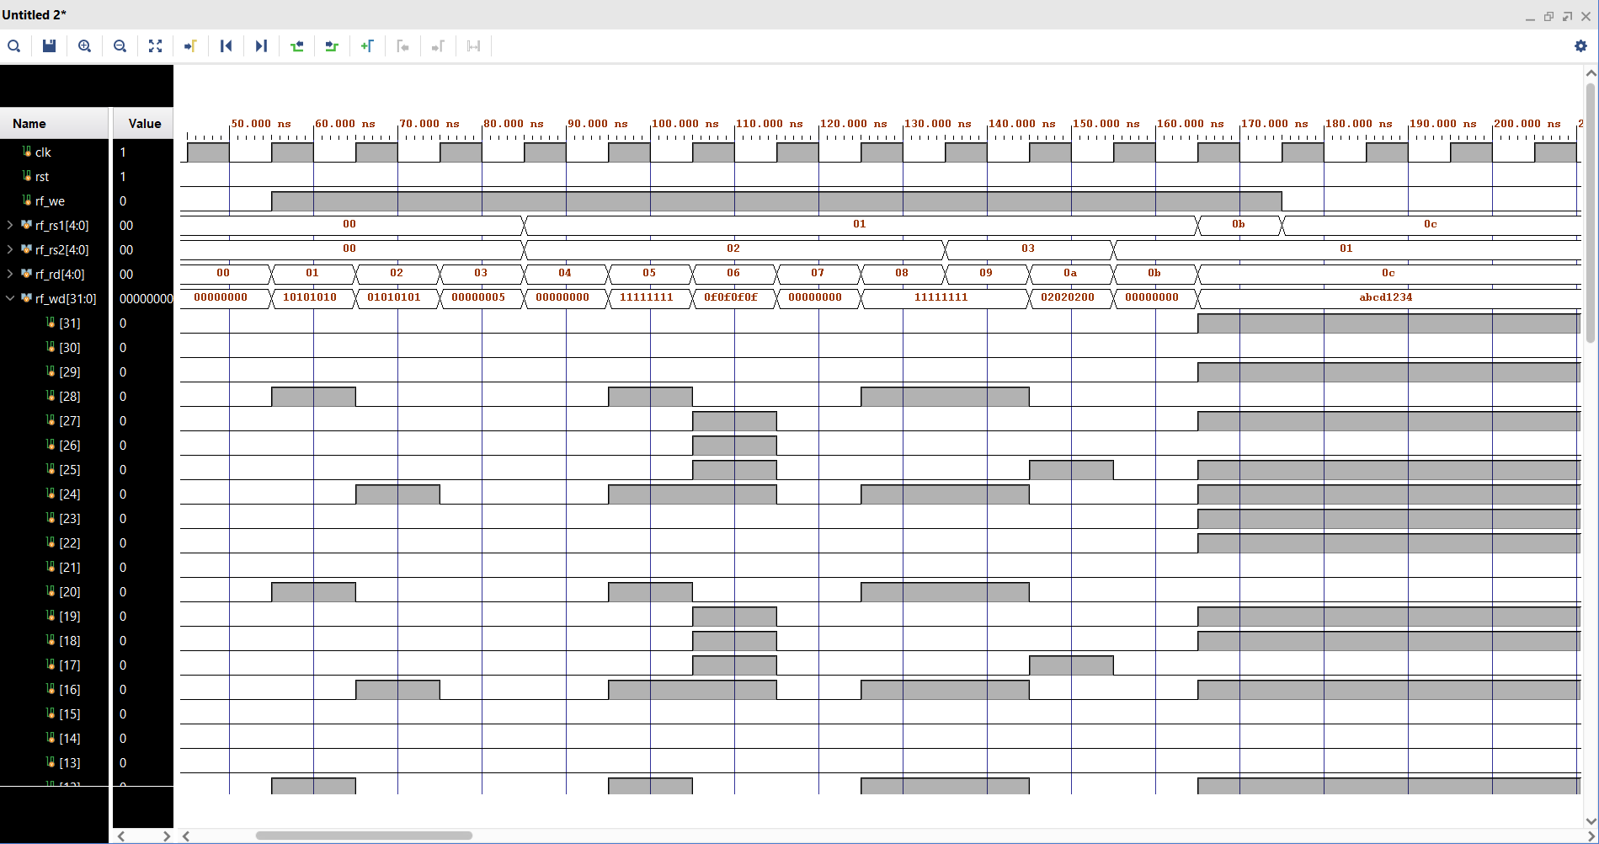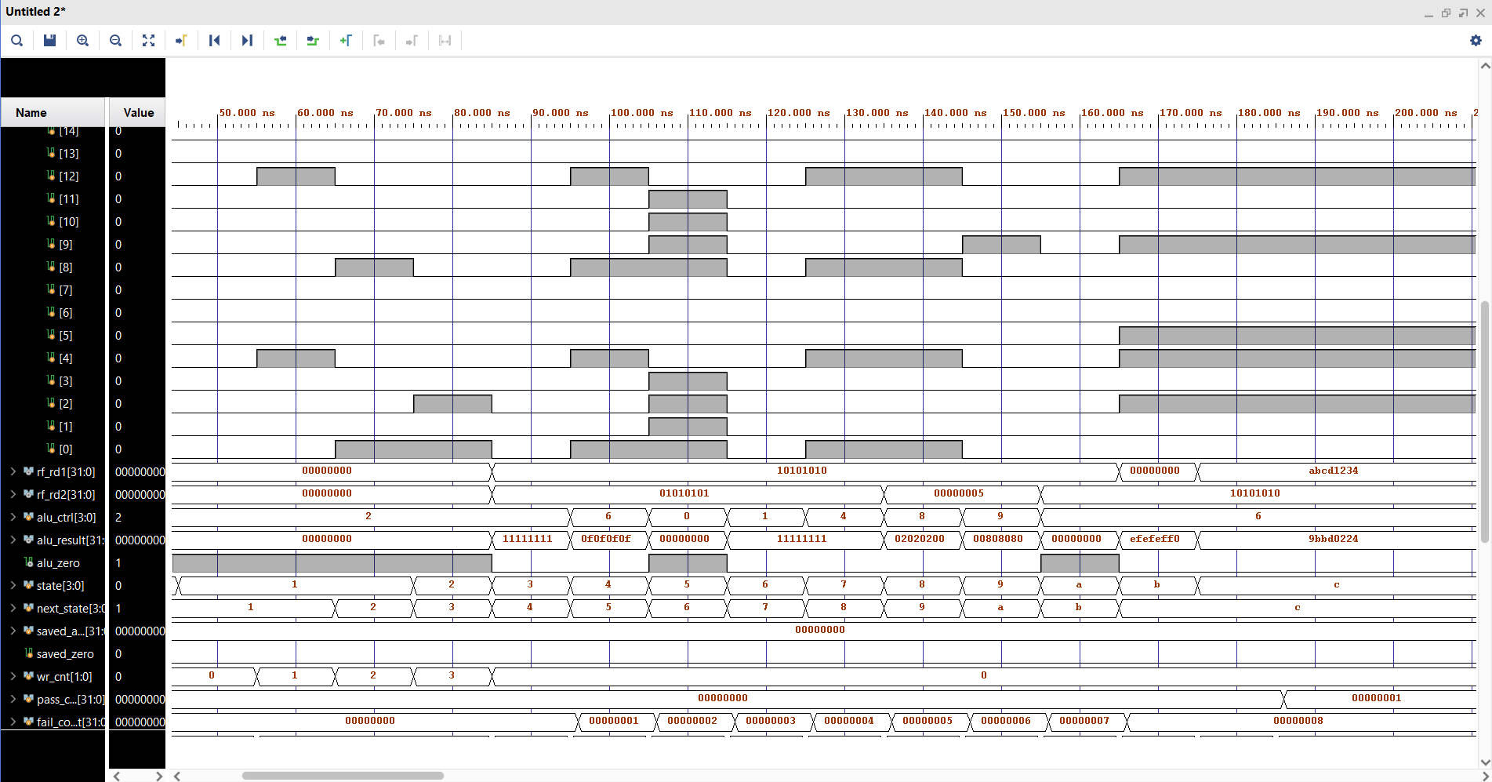

Task 3: FPGA Synthesis and RTL Analysis
Note: The switch interface, button debouncing module, and LED interface must be re used from Lab 5.

RTL schematic screenshots (register file array, decoder, FSM, ALU connections)

[ NEXT PAGE ]

Demonstration of FPGA operation

[ SHOWN TO MISS IN LAB ]

Assessment Rubric
Lab 7: Design and FPGA Implementation of the Register File for a Single-Cycle RISC-V Processor

Name: | Student ID: | Section:

Points Distribution

 | Task No. | LR 2 (Code) | LR 5 (Results) | LR 11  (Design)
In-Lab | Task 1 | - | - | /10
 | Task 2 | /20 | /10 | -
 | Task 3 | /20 | /20 | -
Total Points |  | /40 | /30 | /10
CLO Mapped |  | CLO 1

Affective Domain Rubric |  | Points | CLO Mapped
AR7 | Report Submission & Git Upload | /10 & /10 | CLO 1

CLO | Total Points | Points Obtained
1 | 100
Total | 100

For description of different levels of the mapped rubrics, please refer to the Lab Evaluation Assessment Rubrics and Affective Domain Assessment Rubrics provided here.

